K2320390 – Mudabbir Ahmad
DYOPL – Cl6115 Programming III Assignment
Q1

- Setting Up Your DYOPL Environment [8 marks]
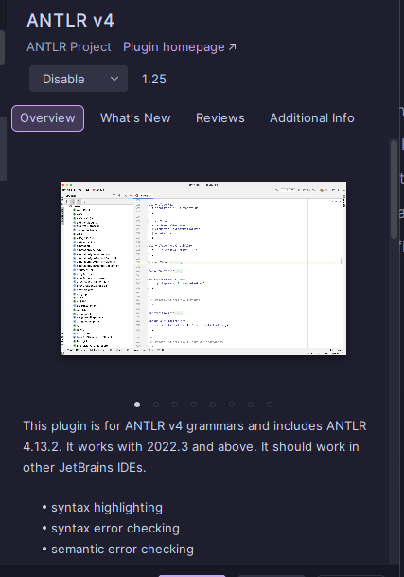
To setup my home desktop environment for the DYOPL project, my first step was to install the ANTLR plugin for my IDE (PyCharm by JetBrains), this plugin was installed to enable syntax highlighting and allow for better debugging, this is also due to it being recommended on the antlr official website.
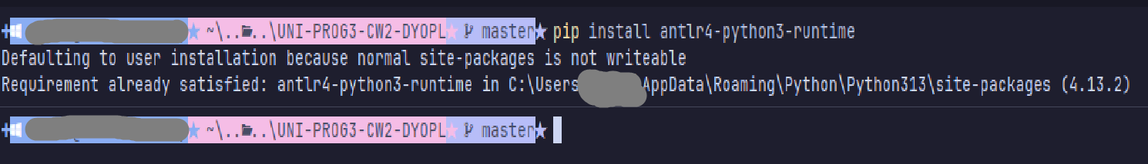
My next step was to install ANTLR on my system via pip and java, I installed the python3-runtime via pip so that my python scripts can execute the antlr grammar files correctly, it was installed to my directory as seen in the screenshot:
After installing the pip package for antlr I decided to install the complete Java antlr.jar I installed the 4.13.2 version of the antlr.jar and placed it in a folder on my C drive called antlr with the path “C:\antlr\antlr-4.13.2-complete.jar” I had also placed it in the CLASSPATH section for my system in environment variables making it executable within my command line with "C:\antlr\antlr-4.13.2-complete.jar” and since there was no environment variable CLASSPATH I had manually created it for my system. [note: the path was pasted in without the quotation marks]
Then appended “;C:\antlr\;” so it’s:
After that I created 2 batch files to execute the antlr4 from within my terminal:
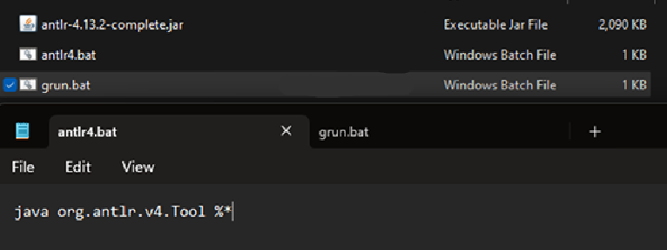
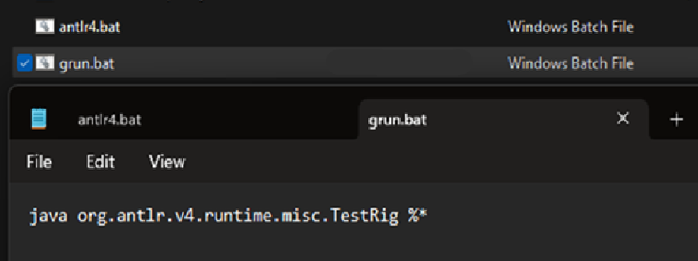antlr4.bat : java org.antlr.v4.Tool %*
grun.bat : java org.antlr.v4.runtime.misc.TestRig %*
Yet even after following these setup instructions I would face issues such as:
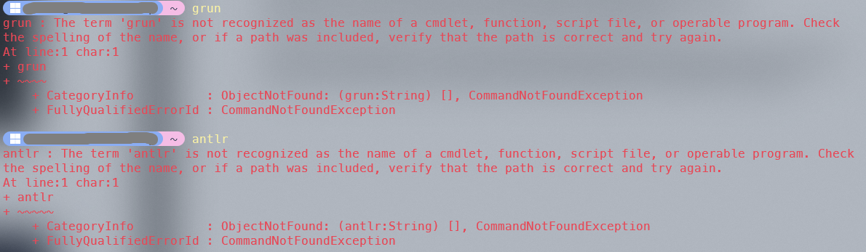
So to fix this I had changed the classpath var to “.;C:\antlr\antlr-4.13.2-complete.jar” and moved the two batch files to my pip install path for my antlr install which was C:\Users\ [My PC USER] \AppData\Roaming\Python\Python313\Scripts
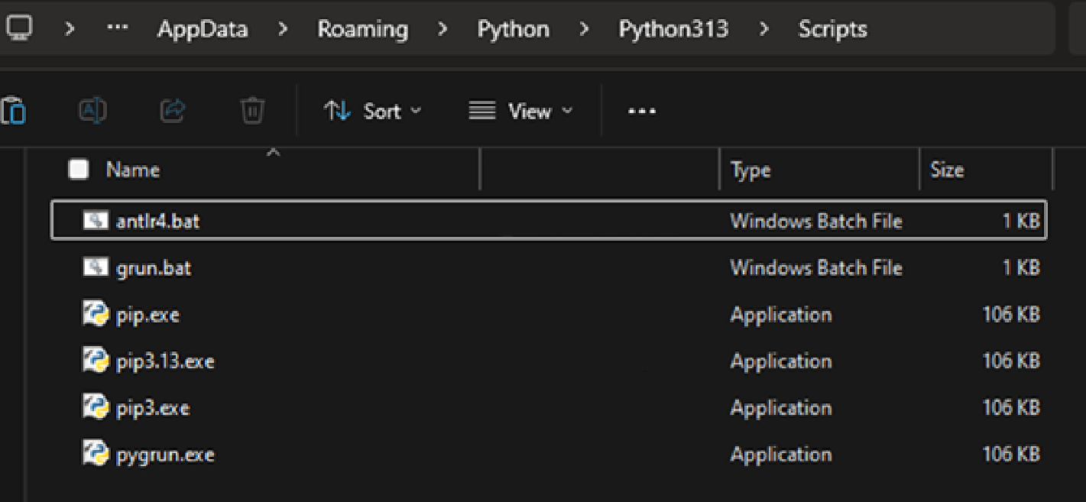
This change had fixed the issue of grun not working but antlr still didn’t work, I suspected that this was because the batch file was called antlr4 not antlr.
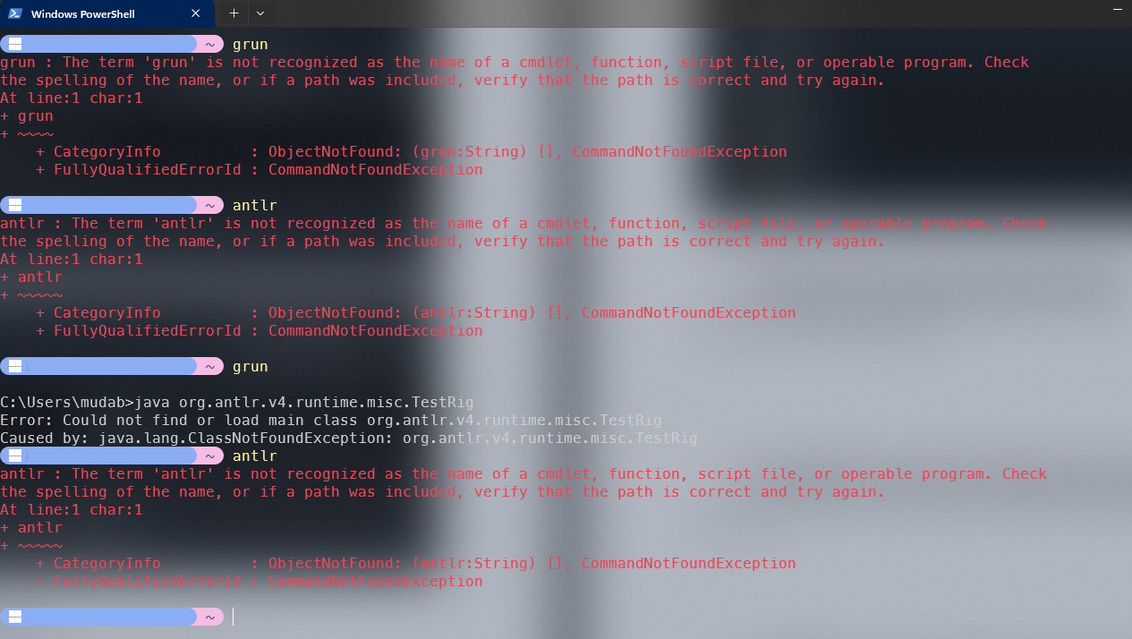
To further fix this issue and to save me time when typing out antlr I created a copy of the antlr4 file and renamed it to antlr, ensuring I have both, to allow for both commands (Alternatively I could have made an alias in the PowerShell profile but windows is quite slow at loading aliases, this is more effective on my UNIX-based systems such as my macOS & ubuntu server, which were at times used to write the grammar files/store grammar files as a backup but my windows system was used to execute them)

Note: My mac OS system had been setup for antlr for use throughout my module however the setup for that was convoluted due to my other services/apps I run on that system and therefore trying to retrace my steps and document that would take too long.
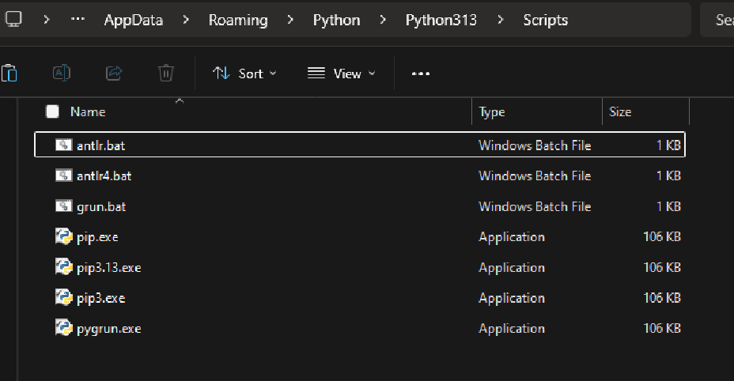
This was confirmed to work:
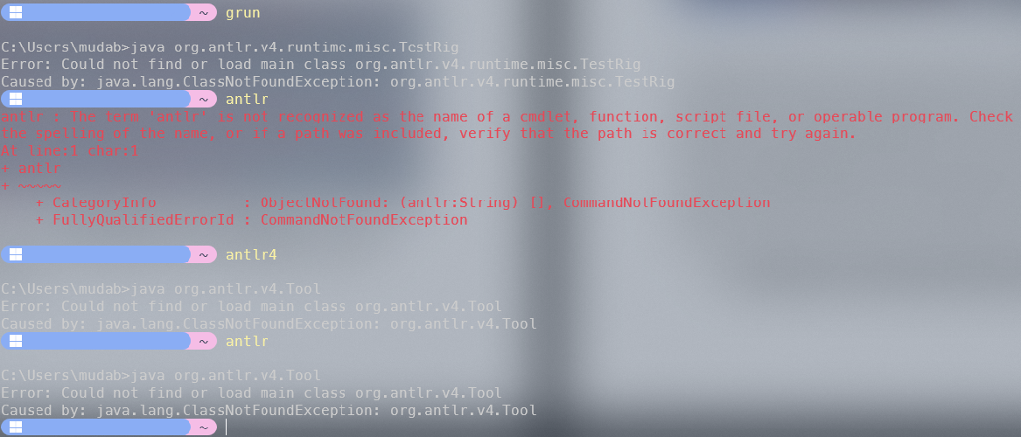
This concluded the setup for my environment as now if I created a grammar file and tried to execute it, it would run.

Tips on setting up Antlr for this module on your own windows system would be to:
Install the complete version of the .jar file and then install python3, follow the python3 installation and get pip working. After that, install antlr via pip for the python3 runtime, before doing this make sure your pip install is up to date, and place the antlr.jar file in a folder called antlr or whatever you want in your C: drive. Following tutorials such as this one might help as it’s where I learnt what sort of bat files, I needed to create for setting up the antlr java instance, these steps weren’t covered in the workshop slides. Place those bat files where your python scripts are for antlr this can be found if you just run the pip install command again for antlr and looking at the output, it should tell you exactly where quite clearly as to find the script files, in that folder place your bat files.

When using PyCharm changing the .bat file might help as it causes issues with the IDE and CLASSPATH, so changing the antlr.bat to:
“java -cp ".;C:\antlr\antlr-4.13.2-complete.jar" org.antlr.v4.Tool %*”
and the grun.bat to:
“java -cp ".;C:\antlr\antlr-4.13.2-complete.jar" org.antlr.v4.gui.TestRig %*”
hardcodes the paths for the antlr complete.jar so there’s no issue with it not being able to find the jar.

Diagram of how I think antlr works:

- Parsing Your Personal Script [8 marks]
The personal script I was given according to my K-Number (K2320390) was:
// STUDENT ID: 2320390
WAIT 1;
RELEASE;
LOG "Log entry 592";
REPEAT 3 {
GRAB;
GRAB;
}
REPEAT 3 {
GRAB;
LOG "Finished 962";
}
REPEAT 4 {
WAIT 2;
MOVE 7;
MOVE 14;
}

When trying to run my Antlr grammar file I got this error:
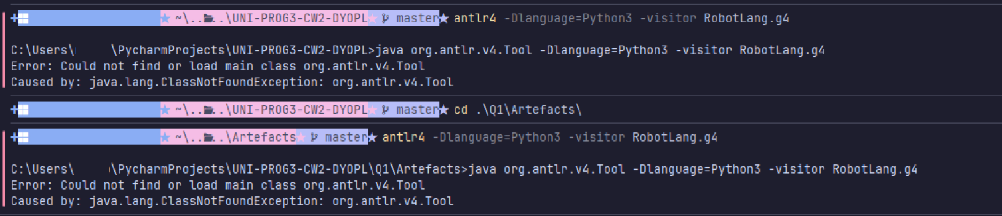
This is partly related to my environment setup.
To fix this I had:

Change the antlr.bat to:
“java -cp ".;C:\antlr\antlr-4.13.2-complete.jar" org.antlr.v4.Tool %*”

Change the grun.bat to:
“java -cp ".;C:\antlr\antlr-4.13.2-complete.jar" org.antlr.v4.gui.TestRig %*”

[Note: Since I had antlr4.bat as well as antlr.bat with them serving the same purpose I applied the same change to antlr4.bat as well as antlr.bat (Again keeping both was just a preference thing as sometimes I use antlr4 as that’s what I’m used to on my MacOS system when I was being taught this for the module but also used to antlr as I like to shorten my commands and getting rid of a number makes it easier for me to type it almost instantly, coming from a person who aliased clear to cl)]

After this change the Grammar file was now ready to be used.
The error seen in the Screenshot is from syntax error with my grammar file’s code.

Moving on to the actual execution of the grammar file.

I create a txt file called MyScript.txt and in it I include the script given to my K number.
I then create a main.py. I place both these files within my artefact’s subfolder in which my grammar file lies.

When I create the main.py Pycharm prompts me to select a python interpreter for my code. I select my local instance and set it up to use python 3.14 as that’s what I have installed on my windows system.
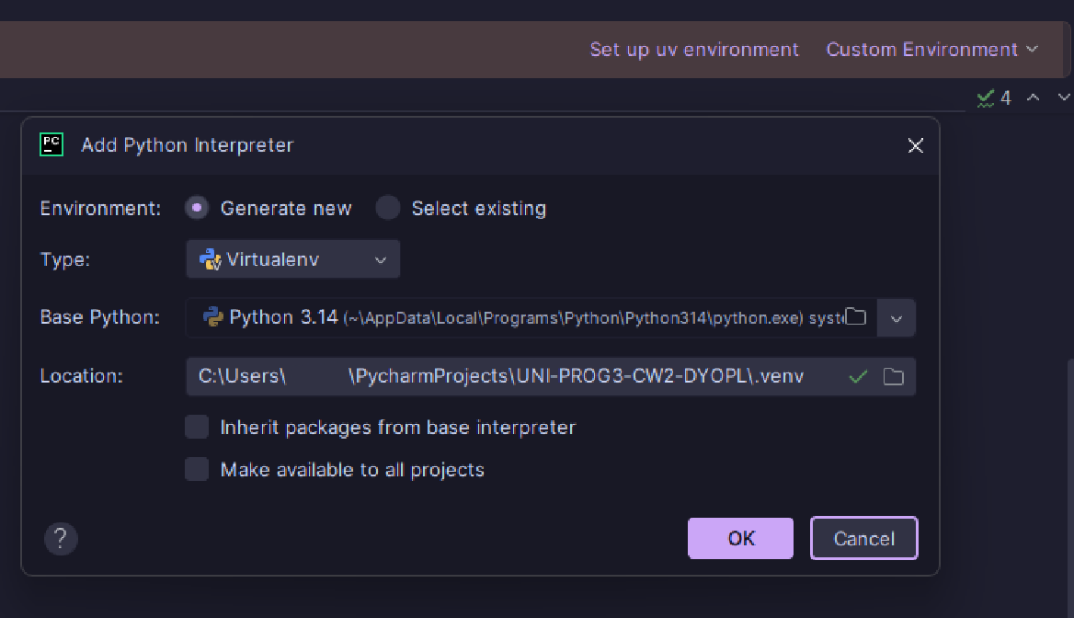
I checked of both the boxes for inheriting packages and making it available to all projects. This wasn’t needed but I had done it anyways.

My next step was to implement changes into the RobotLangVisitor.py file that was made with the antlr commands earlier:
antlr -Dlanguage=Python3 -visitor RobotLang.g4

I added some functionality to the visitor file as currently when a step is called upon it doesn’t really execute anything due to all of its functions having a simple return statement as per generated by antlr:
return self.visitChildren(ctx)

These changes weren’t applied to the actual generated visitor file yet another file I manually made which was a copy paste of the visitor file, this was renamed to RobotLangVisitorUser.py, this was done so whenever I ran the antlr command earlier to initialise my grammar file it doesn’t overwrite changes made, as editing pre-generated code would be useless due to it being overwritten.
In this new python file I had added functionality to the visitor user class in the methods visitMoveStat, visitGrabStat, visitReleaseStat, visitWaitStat, visitLogStat, and visitRepeatStat
Instead of leaving the default return self.visitChildren(ctx) instruction, I replaced it with Python print() statements. As taught in the module's "grammar-parse-walk" workflow, the purpose of these print statements is to act as the actual execution of the script. Since this is a simulation language and there is no physical robot to move or grab, printing to the console serves as the program's output.
To make the execution dynamic, I utilized the context parameter (ctx), which the ANTLR parser passes to the visitor. The ctx object carries information about the currently visited node in the abstract syntax tree, allowing me to extract the exact tokens the user inputted. For example, in the MOVE and WAIT commands, I used ctx.NUMBER().getText() to extract the specific integer from the script and inject it into the output.

I had also added an init constructor to the class that would retrieve my student ID from the MyScript.txt so when it creates its outputs later, it would state things such as K2320390 is grabbing, k2320390 is moving by N, etc.

Originally the init constructor had my K number hardcoded and that worked with the grammar file being:
grammar RobotLang;
prog: stat+ ;
stat: moveStat
| grabStat
| releaseStat
| waitStat
| logStat
| repeatStat
;
moveStat: 'MOVE' NUMBER ';' ;
grabStat: 'GRAB' ';' ;
releaseStat: 'RELEASE' ';' ;
waitStat: 'WAIT' NUMBER ';' ;
logStat: 'LOG' STRING ';' ;
repeatStat: 'REPEAT' NUMBER '{' stat+ '}' ;
NUMBER: [0-9]+ ;
STRING: '"' .*? '"' ;
WS: [ \t\r\n]+ -> skip ;

But this meant that regardless of the K number in the script it would retrieve my set K number instead of the script one. So to change this I updated my grammar file:
grammar RobotLang;

prog: header stat+ ;
header: ID_PREFIX NUMBER ;
stat: moveStat
| grabStat
| releaseStat
| waitStat
| logStat
| repeatStat
;

moveStat: 'MOVE' NUMBER ';' ;
grabStat: 'GRAB' ';' ;
releaseStat: 'RELEASE' ';' ;
waitStat: 'WAIT' NUMBER ';' ;
logStat: 'LOG' STRING ';' ;
repeatStat: 'REPEAT' NUMBER '{' stat+ '}' ;

ID_PREFIX: '// STUDENT ID:' ;
NUMBER: [0-9]+ ;
STRING: '"' .*? '"' {self.text = self.text[1:-1]} ;
WS: [ \t\r\n]+ -> skip ;

However running this script now without the init constructor I would get errors:
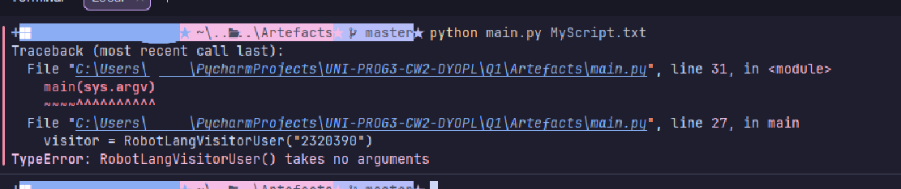

This was due to the fact that my main.py hadn’t been updated and was parsing my K-Number into my visitor class which wasn’t expecting any parameters.

To fix this I updated my class by adding:
def __init__(self):
self.student_id = "Unknown"

def visitHeader(self, ctx):
self.student_id = ctx.NUMBER().getText()
return self.visitChildren(ctx)

the “unknown” acted as a placeholder for when the visitorUser is called upon without the Knumber being parsed to it. I also added a visitHeader method, this function’s purpose was to look at the header of the Scripts which were outlined by // STUDENT ID: [value], so this was to extract the number values from that 1st line.

- Executing Your Script via Python [10 marks]
My scripts:

- Reflections on Your Experience [4 marks]
My experience with the Grammer and Visitor:

Suppose the client now wants to support variables (e.g., SET speed = 10). What
would you need to change in your grammar and visitor? What new complexities
would arise? Print your code, annotate the changes needed by hand with a pen,
photograph the annotated pages, and submit only the photographs.

[Done with a PDF Viewer, as I had asked this during a lecture and it was stated to me that PDF viewers to hand draw the annotations instead of printing and annotating is accepted.]

