K2320390 – Mudabbir Ahmad
DYOPL – Cl6115 Programming III Assignment
Q1

- Setting Up Your DYOPL Environment [8 marks]
To establish a functional development environment for the DYOPL project, the following installation process was executed on my Windows-based system. A lot of the instructions were derived from this website alongside the university provided guide via the DYOPL Lecture slides

IDE Integration
The primary Integrated Development Environment (IDE) utilized was PyCharm by JetBrains. The ANTLR v4 plugin (supporting version 4.13.2) was integrated to provide essential development features, including:

Advanced syntax highlighting for .g4 files.
Real-time syntax and semantic error checking.
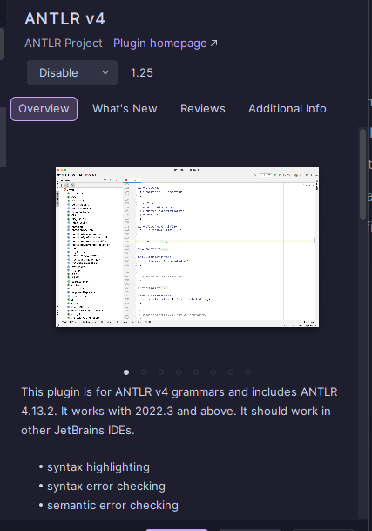
Enhanced debugging capabilities as per official ANTLR recommendations.

Runtime and Tooling Installation
The system was configured with both the Python runtime and the Java-based ANTLR toolset:
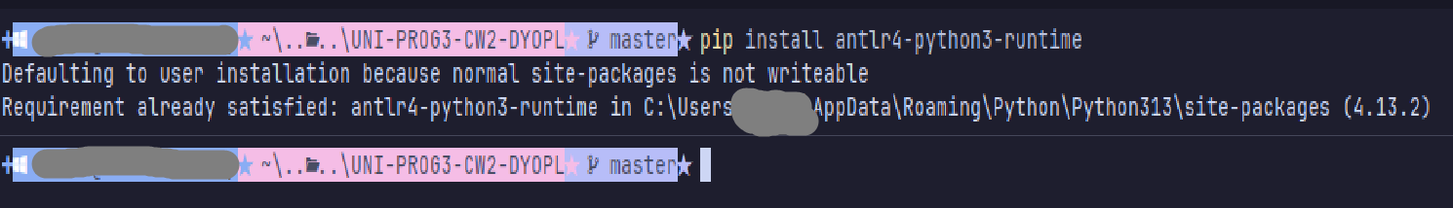
Python Runtime: The antlr4-python3-runtime was installed via pip to facilitate the execution of generated grammar files within Python scripts.
Java Toolset: The antlr-4.13.2-complete.jar was downloaded and situated in a root-level directory (C:\antlr\) to simplify path referencing.
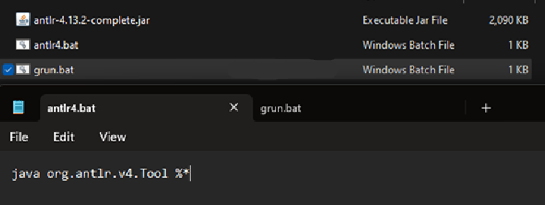

Environment Variables and Path Configuration
To ensure global accessibility of the ANTLR tools, system-level environment variables were manually configured:
CLASSPATH: Created to point directly to the .jar file. It was later changed to .;C:\antlr\antlr-4.13.2-complete.jar to ensure Java includes the current working directory during lookups.
Path Files: The directory C:\antlr\ was appended to the system PATH.

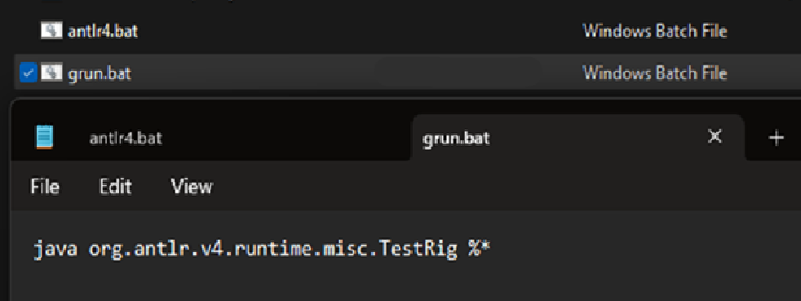

antlr4.bat:
java org.antlr.v4.Tool %*
grun.bat:
java org.antlr.v4.runtime.misc.TestRig %*

Errors Encountered During Setup:

Cmdlet Not Recognized: After creating the CLASSPATH and .bat files, I tried to run the commands in PowerShell but received a "cmdlet not recognized" error. I diagnosed that Windows terminals do not dynamically update environment variables. I had to completely restart my PowerShell terminal and ensure my .bat files were in a folder explicitly listed in my PATH variable to resolve this. Furthermore, I had formatted my CLASSPATH incorrectly. I updated it to “.;C:\antlr\antlr-4.13.2-complete.jar” (adding the ”.;” to ensure Java looks in the current working directory).

ClassNotFoundException: When attempting to run the build command inside PyCharm's integrated terminal, I received a java.lang.ClassNotFoundException: org.antlr.v4.Tool. I realised this issue was due to the .jar file not being successfully found by the scripts. I discovered that I had accidentally placed the two .bat files in the C:\antlr folder instead of the Python Scripts folder. It was unclear to me exactly where to place them based on the initial installation instructions. I then found a helpful website covering the antlr install which clarified the correct directory. I fixed the issue by moving the .bat files into my Python scripts folder and modifying them to hardcode the -cp argument, ensuring the tool could always locate the .jar file no matter what.
antlr.bat: java -cp ".;C:\antlr\antlr-4.13.2-complete.jar" org.antlr.v4.Tool %*

grun.bat: java -cp ".;C:\antlr\antlr-4.13.2-complete.jar" org.antlr.v4.gui.TestRig %*

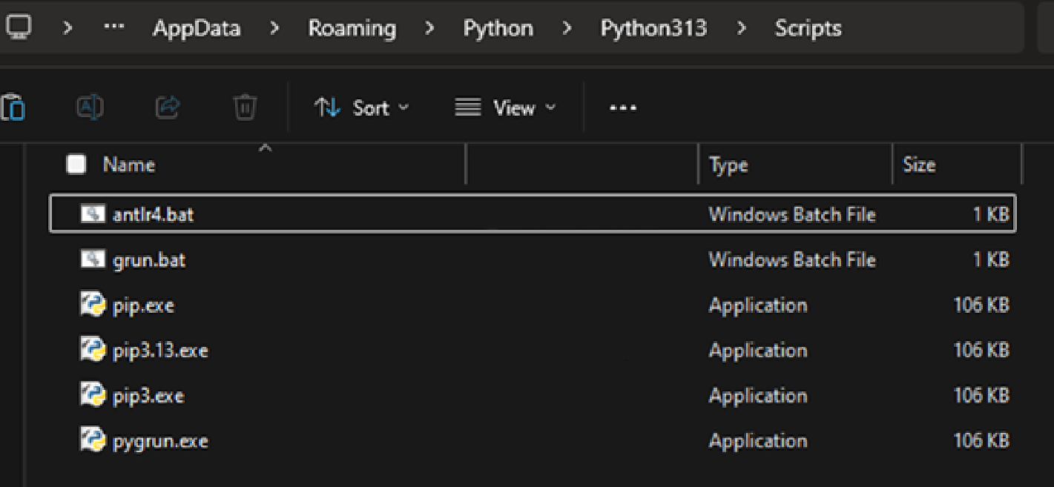
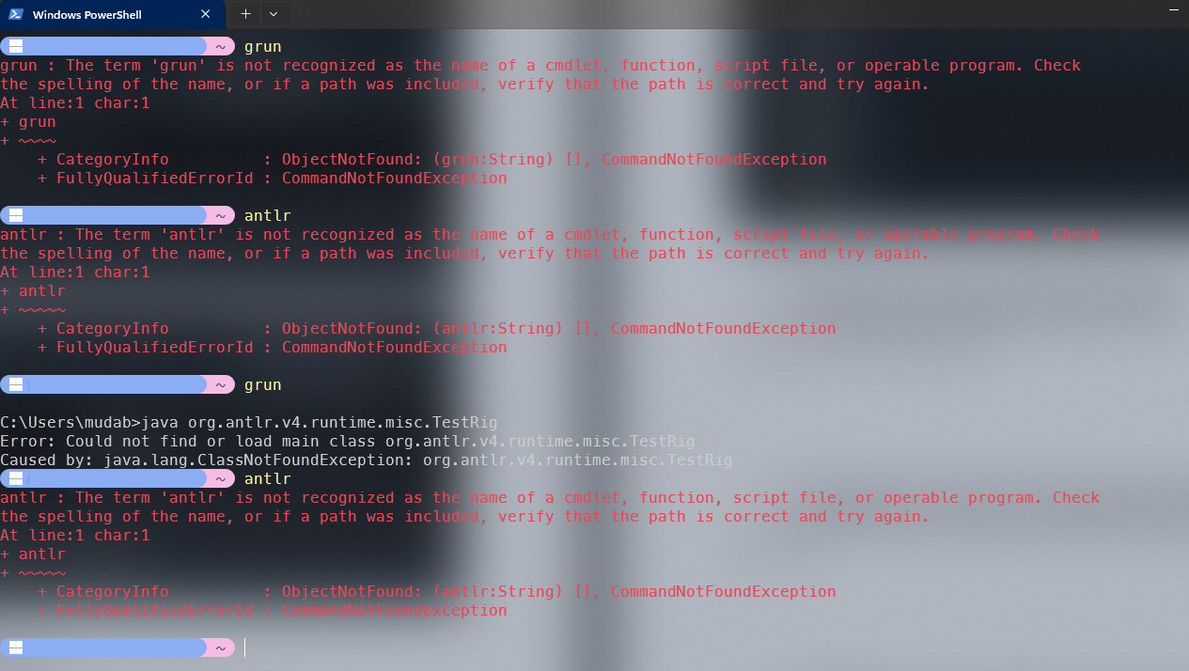

[Note: Since I had antlr4.bat as well as antlr.bat with them serving the same purpose I applied the same change to antlr4.bat as well as antlr.bat (Again keeping both was just a preference thing as sometimes I use antlr4 as that’s what I’m used to on my MacOS system when I was being taught this for the module but also used to antlr as I like to shorten my commands and getting rid of a number makes it easier for me to type it almost instantly, coming from a person who aliased clear to cl)]

[Note: My mac OS system had been setup for antlr for use throughout my module however the setup for that was convoluted due to my other services/apps I run on that system and therefore trying to retrace my steps and document that would take too long.]

Just before running the grammar file I had to set my python interpreter for PyCharm, I had done this via the warning the IDE gave me:
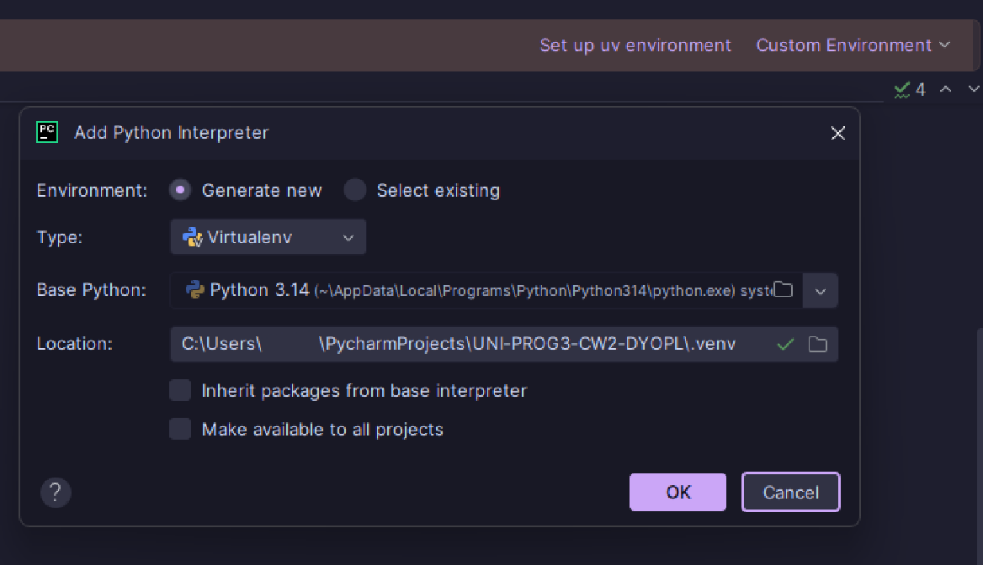

Note: I had checked the two boxes at the bottom of that dialogue box, it’s not necessary for the project but I had done it regardless so that this python environment could be applied to any other grammar project that I might have.

Tips for Others:
Install the complete .jar file and place it in a simple root directory like C:\antlr.
Use pip to install the python3 runtime.
To ensure your commands are recognised, make absolutely sure you place your .bat executable files in your Python Scripts folder (e.g., AppData\Roaming\Python\Python313\Scripts), not in the ANTLR jar folder.
Hardcode the -cp path directly into your .bat executable files to avoid any ClassNotFoundException errors.
Always completely restart your terminal after changing environment variables.

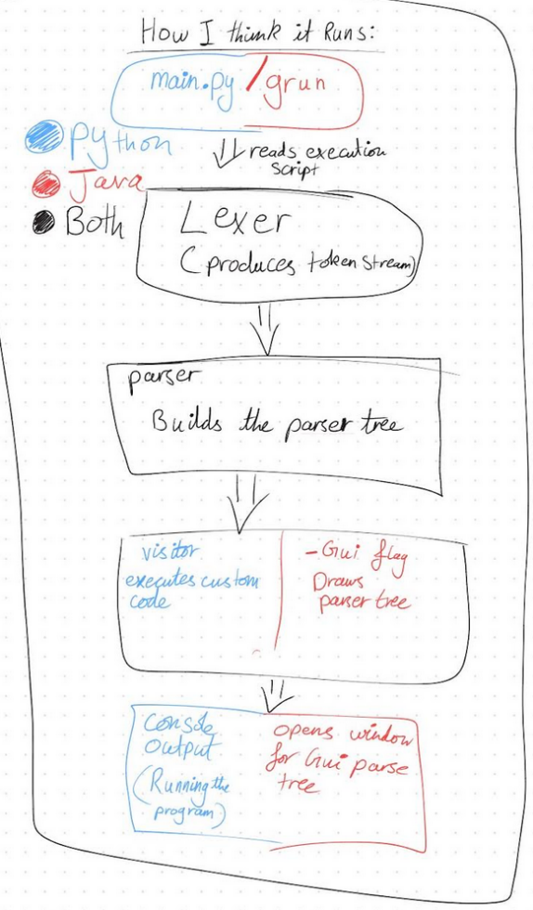
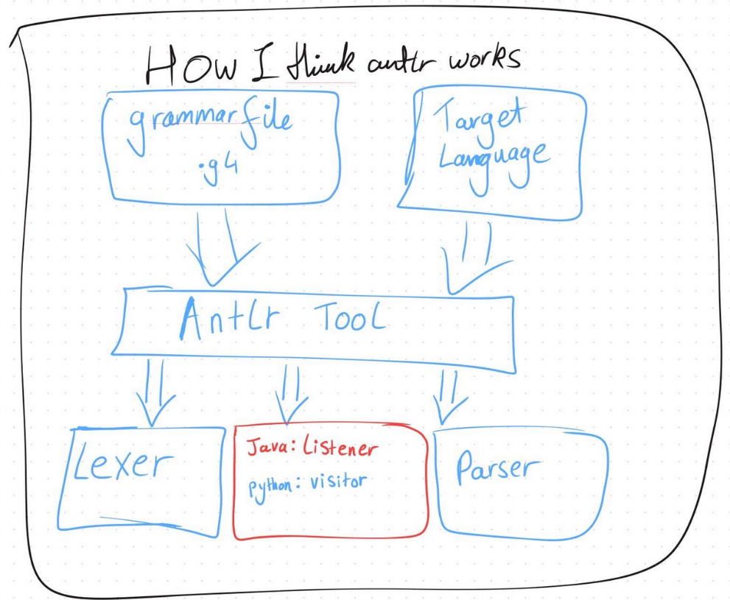
Diagram of how I think antlr works:
- Parsing Your Personal Script [8 marks]
The personal script I was assigned according to my K-Number (K2320390) was:

// STUDENT ID: 2320390
WAIT 1;
RELEASE;
LOG "Log entry 592";
REPEAT 3 {
GRAB;
GRAB;
}
REPEAT 3 {
GRAB;
LOG "Finished 962";
}
REPEAT 4 {
WAIT 2;
MOVE 7;
MOVE 14;
}

I created a file named RobotLang.g4 to recognise these commands. Which I then used to generate both Java classes (for the GUI parse tree) and Python classes (for execution) without conflict.
My final working grammar file (RobotLang.g4):

grammar RobotLang;
prog: header stat+ ;
header: ID_PREFIX NUMBER ;
stat: moveStat
| grabStat
| releaseStat
| waitStat
| logStat
| repeatStat
;
moveStat: 'MOVE' NUMBER ';' ;
grabStat: 'GRAB' ';' ;
releaseStat: 'RELEASE' ';' ;
waitStat: 'WAIT' NUMBER ';' ;
logStat: 'LOG' STRING ';' ;
repeatStat: 'REPEAT' NUMBER '{' stat+ '}' ;
ID_PREFIX: '// STUDENT ID:' ;
NUMBER: [0-9]+ ;
STRING: '"' .*? '"' ;
WS: [ \t\r\n]+ -> skip ;

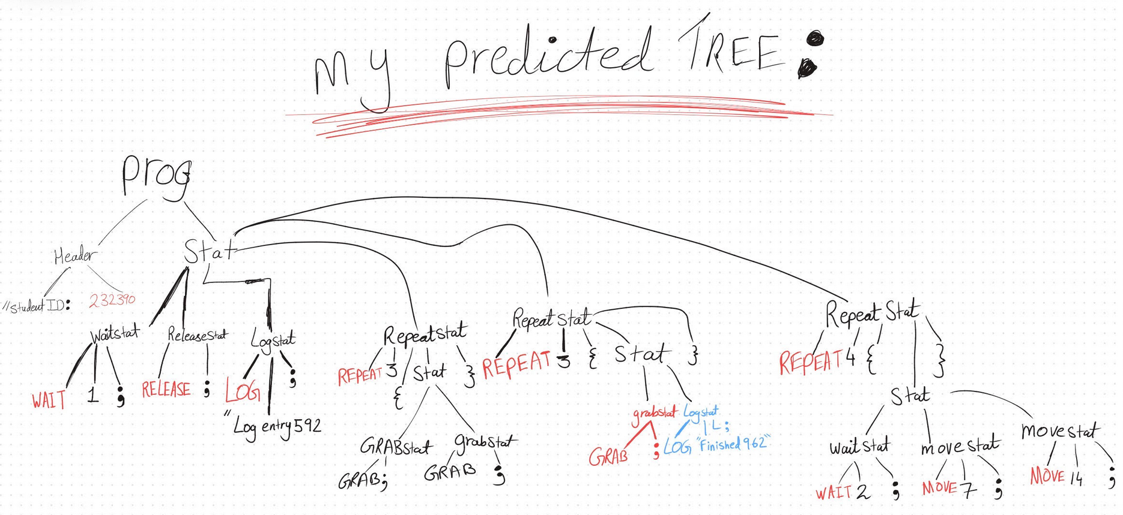
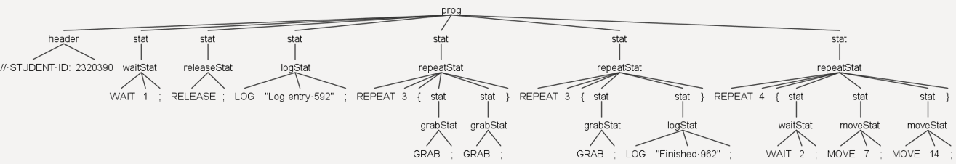
(This image is also available in the artefacts section)

The differences between the tree I expected and the tree that was drawn at the end was that I didn’t expect each taskNode e.g Log or Wait etc. would have their own unique stat parent node. This was something I didn’t expect in both the 1st child from prog and the 3rd child from prog. Other than that most of what I expected was there, as derived from MyScript.txt

- Executing Your Script via Python [10 marks]

My Script | Executed as:
// STUDENT ID: 2320390  WAIT 1;  RELEASE;  LOG "Log entry 592";  REPEAT 3 {  GRAB;  GRAB;  }  REPEAT 3 {  GRAB;  LOG "Finished 962";  }  REPEAT 4 {  WAIT 2;  MOVE 7;  MOVE 14;  } | 2320390 is waiting for 1.  2320390 is releasing.  2320390 is logging: Log entry 592.  2320390 is grabbing.  2320390 is grabbing.  2320390 is grabbing.  2320390 is grabbing.  2320390 is grabbing.  2320390 is grabbing.  2320390 is grabbing.  2320390 is logging: Finished 962.  2320390 is grabbing.  2320390 is logging: Finished 962.  2320390 is grabbing.  2320390 is logging: Finished 962.  2320390 is waiting for 2.  2320390 is moving by 7.  2320390 is moving by 14.  2320390 is waiting for 2.  2320390 is moving by 7.  2320390 is moving by 14.  2320390 is waiting for 2.  2320390 is moving by 7.  2320390 is moving by 14.  2320390 is waiting for 2.  2320390 is moving by 7.  2320390 is moving by 14.

I Ran the script via running these commands to run the Python script for main.py:
antlr4 -Dlanguage=Python3 -visitor RobotLang.g4
python main.py MyScript.txt

For the Grun tree:
javac -cp ".;C:\antlr\antlr-4.13.2-complete.jar" *.java
javac -cp ".;C:\antlr\antlr-4.13.2-complete.jar" *.java
grun RobotLang prog -gui MyScript.txt

The output for the Python run was as:
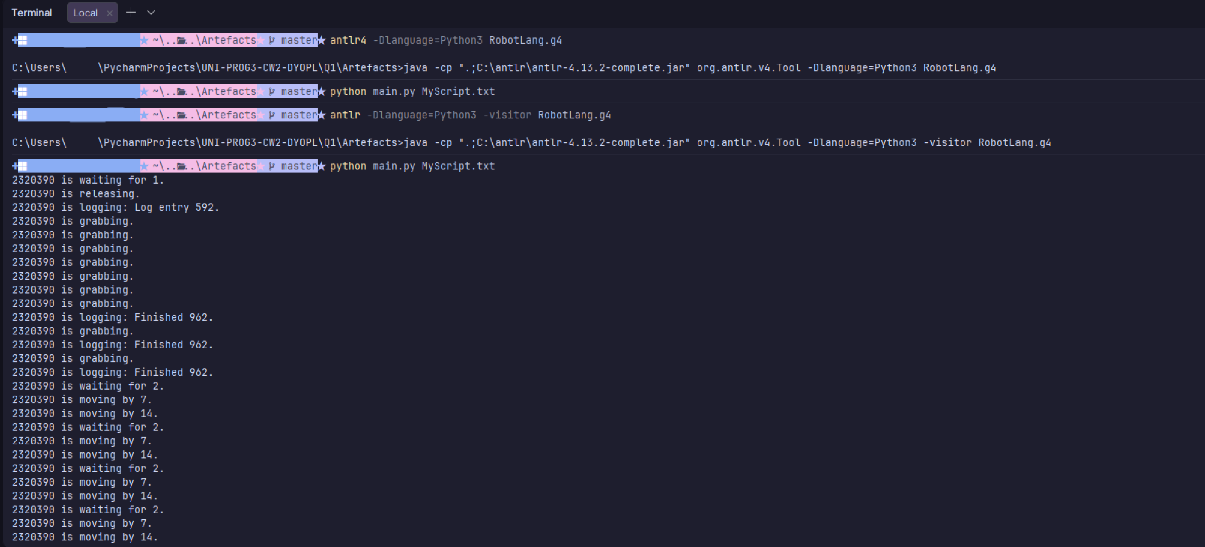

Structure for Grammar file and Visitor File annotated:

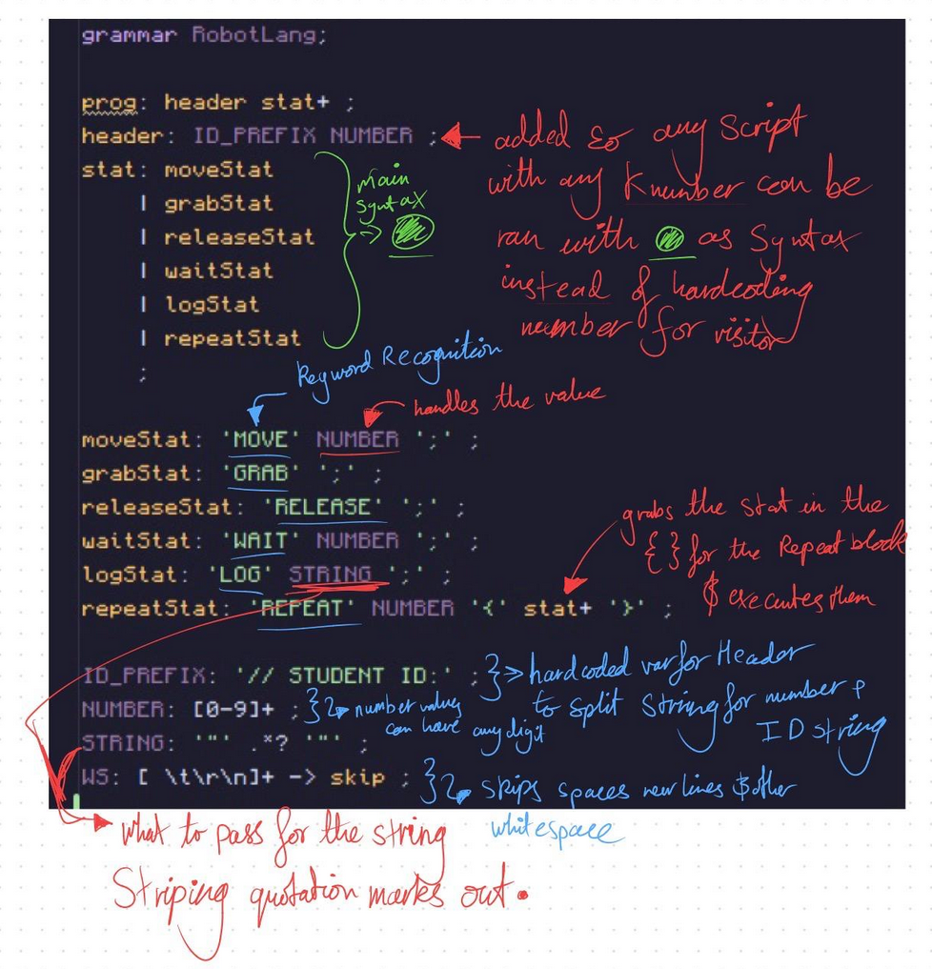
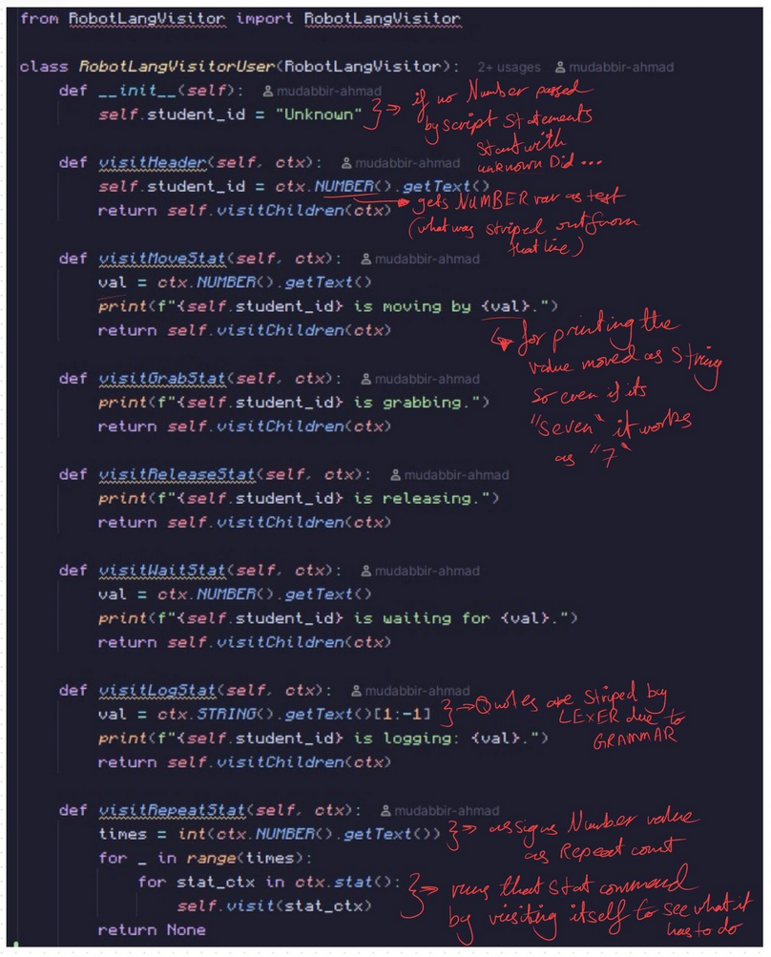

- Reflections on Your Experience [4 marks]

Instead of listing the problems I faced in the earlier sections of this document, I have compiled all the challenges, surprising behaviours, and errors I encountered throughout the setup, grammar creation, and execution phases here, along with exactly how I resolved them.

Surprising Errors and Problems Encountered:

- Cmdlet Not Recognized (Setup Phase): After creating the CLASSPATH and .bat files, I tried to run the commands in PowerShell but received a "cmdlet not recognized" error. I diagnosed that Windows terminals did not update to use the new environment variables. I had to completely restart my PowerShell terminal and ensure my .bat files were in a folder explicitly listed in my PATH variable to resolve this. I also had formatted my CLASSPATH incorrectly. I updated it to .;C:\antlr\antlr-4.13.2-complete.jar (adding the .; to ensure Java looks in the current working directory).

- Token Recognition Error (Grammar Phase): When I first tested the grammar against my assigned script, the terminal threw a red token recognition error at: '/' at line 1. I realised I had not defined a rule to handle the // characters, causing the lexer to crash the moment it hit // STUDENT ID: 2320390. I initially resolved this by adding a COMMENT skip rule, but I later refactored it into a formal header rule. By integrating the ID into the formal Abstract Syntax Tree (AST), I was able to dynamically extract my K-number later in my Python execution script, without leaving it hardcoded.
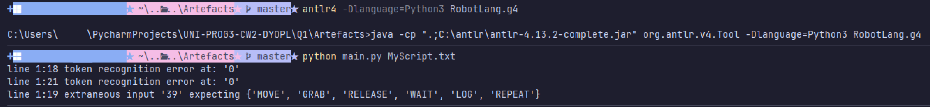

- Java Compiler Path Error (Grammar Phase): To view my graphical parse tree using ANTLR's TestRig (grun), I attempted to compile the generated Java targets using javac *.java. However, I received the error package org.antlr.v4.runtime does not exist. I deduced that because my Windows terminal was struggling with the global CLASSPATH, the Java compiler was flying blind and could not locate the ANTLR library. I fixed this by manually injecting the classpath into the compile command:
javac -cp ".;C:\antlr\antlr-4.13.2-complete.jar" *.java.
This error was especially strange due to the fact that the batch file for antlr and antlr4 worked perfectly fine, only the grun.bat batch file had issues interacting with the jar file.

- ModuleNotFoundError (Execution Phase): I ran my build command but received a ModuleNotFoundError: No module named 'RobotLangVisitorUser' when trying to run my python script. I realised that the default ANTLR build command only generates a Listener class. I had to update my terminal command to explicitly include the Visitor flag: antlr4 -Dlanguage=Python3 -visitor RobotLang.g4 to generate the correct base files.

- RobotLangVisitor.py: Initially when I was editing the robotlangvisitor file I would edit the file and re-init the grammar file, this turns out would regenerate the robotlangvisitor file, undoing all my changes, I realised this after the first run, however due to me using github to keep track of my changes, I was able to look at my private repo and rollback the code to before the file was overwritten and save it to an external file that wouldn’t be overwritten, called RobotLangVisitorUser.py.

Adding Variables (e.g., SET speed = 10):

If we wanted to support variables. The grammar would need a new assignment rule (e.g., setStat: 'SET' ID '=' NUMBER ';' ;) and an ID lexer rule to recognise variable names (e.g., ID: [a-zA-Z]+ ;).

In the Python visitor, I would need to establish a global dictionary, such as self.variablesTable = {}, inside the __init__ constructor. When visiting the setStat node, the visitor would store the ID string as the dictionary key and the NUMBER as the mapped value.

The major new complexity this introduces is semantic checking. If a user inputs MOVE speed;, the syntactic parser will allow it, but the visitMoveStat method must now contain Python logic to verify that the string "speed" actually exists in self.variablesTable before attempting to execute the move. If it has not been previously set, the visitor must throw a custom "Identifier not found" error to prevent runtime crashes.

