K2320390 – Mudabbir Ahmad
DYOPL – Cl6115 Programming III Assignment
Q1

- Setting Up Your DYOPL Environment [8 marks]
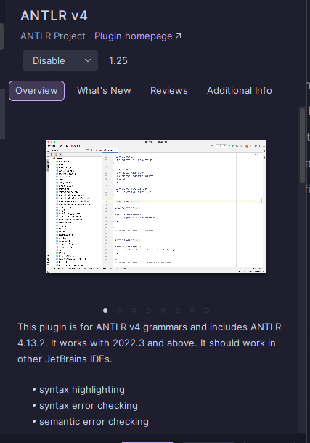
To setup my home desktop environment for the DYOPL project, my first step was to install the ANTLR plugin for my IDE (Pycharm by JetBrains), this plugin was installed to enable syntax highlighting and allow for better debugging, this is also due to it being recommended on the antlr official website.
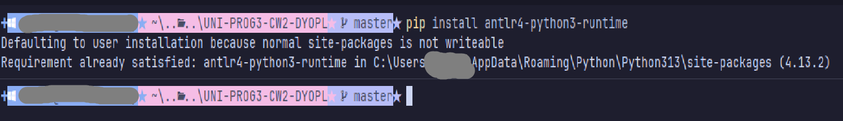
My next step was to install ANTLR on my system via pip and java, I installed the python3-runtime via pip so that my python scripts can execute the antlr grammar files correctly, it was installed to my directory as seen in the screenshot:

After installing the pip package for antlr I decided to install the complete Java antlr.jar I installed the 4.13.2 version of the antlr.jar and placed it in a folder on my C drive called antlr with the path “C:\antlr\antlr-4.13.2-complete.jar” I had also placed it in the CLASSPATH section for my system in environment variables making it executable within my command line with "C:\antlr\antlr-4.13.2-complete.jar” and since there was no environment variable CLASSPATH I had manually created it for my system. [note: the path was pasted in without the quotation marks]
Then appended ;C:\antlr\; so its:
After that I created 2 batch files to execute the antlr4 from within my terminal:
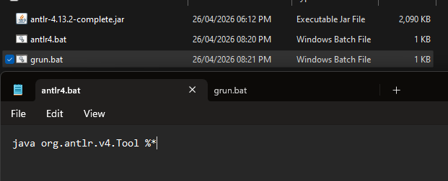
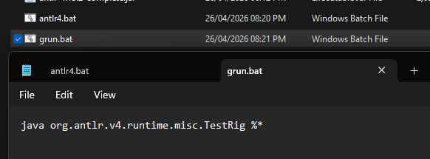antlr4.bat : java org.antlr.v4.Tool %*
grun.bat : java org.antlr.v4.runtime.misc.TestRig %*

- Parsing Your Personal Script [8 marks]
My personal Scripts being parsed:

- Executing Your Script via Python [10 marks]
My scripts:

- Reflections on Your Experience [4 marks]
My experience with the Grammer and Visitor:

Suppose the client now wants to support variables (e.g., SET speed = 10). What
would you need to change in your grammar and visitor? What new complexities
would arise? Print your code, annotate the changes needed by hand with a pen,
photograph the annotated pages, and submit only the photographs.

[Done with a PDF Viewer, as I had asked this during a lecture and it was stated to me that PDF viewers to hand draw the annotations instead of printing and annotating is accepted.]

